**CS6612 – Compiler Lab**

**Ex no : 6 Name : Sreedhar V**

**Date : 02.03.2021 Reg no: 185001161**

Programming Assignment-6 **-** Implementation of Syntax Checker using Yacc Tool

Develop a Syntax checker to recognize the tokens necessary for the following statements by writing suitable grammars

Assignment statement

Conditional statement

Looping statement

**Code**

*(*%{

#include<stdio.h>

#include<string.h>

#include"syn_ch.tab.h"

%}

id ([a-zA-Z_][a-zA-Z0-9_]*|[0-9]+)

rl ("<"|"<="|">"|">="|"=="|"!=")

op ("+"|"-"|"*"|"/"|"%")

un ("++"|"--")

nl "\n"

ts "\t"|" "

%%

"if" {return IF;}

"else" {return ELSE;}

"while" {return WHILE;}

"do" {return DO;}

"for" {return FOR;}

{id} {return ID;}

{rl} {return RL;}

{op} {return OP;}

{un} {return UN;}

{nl} {return NL;}

{ts} ;

. return yytext[0];

%%

int yywrap(){return 1;}

*file)*

*(yacc file)*

%{

#include <stdio.h>

int yyerror(char *er);

int yylex(void);

#include <math.h>

#include<stdlib.h>

%}

%token INT STR ID RELOP ARITHOP UNOP DATATYPE IF ELSE

%%

S   : DATATYPE VAR';'|VAR';'|CONDT

VAR : VAR ',' INIT | INIT

INIT : ID | EXPR

EXPR : ID'='ST | ID UNOP | ID'='ID ARITHOP ST | ID'='ID | ID ARITHOP '=' INT

ST : INT|STR|ID

CONDT :IF '(' CONDT_EXP ')' | ELSE

CONDT_EXP : ID RELOP CONDT_EXP | INT RELOP CONDT_EXP | ID | INT

%%

int main()

{

    while(1)

    {

        yyparse();

    }

    return 0;

}

*(Output)*

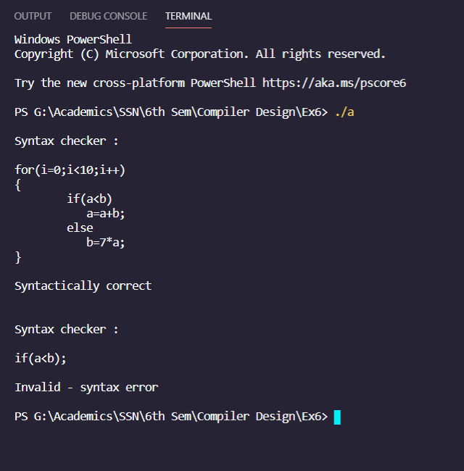

**Learning Outcome:**

* I’ve learnt how to implement the syntax checker considering all its grammar rules and syntax for C language while execution.
* I’ve learnt the basic syntax of the yacc program and how to implement the grammar rules in c code.
* I’ve leant how the lex program sends the token based on its syntax and yacc program evaluates the stream of tokens based on the given grammar rules and produces the result.